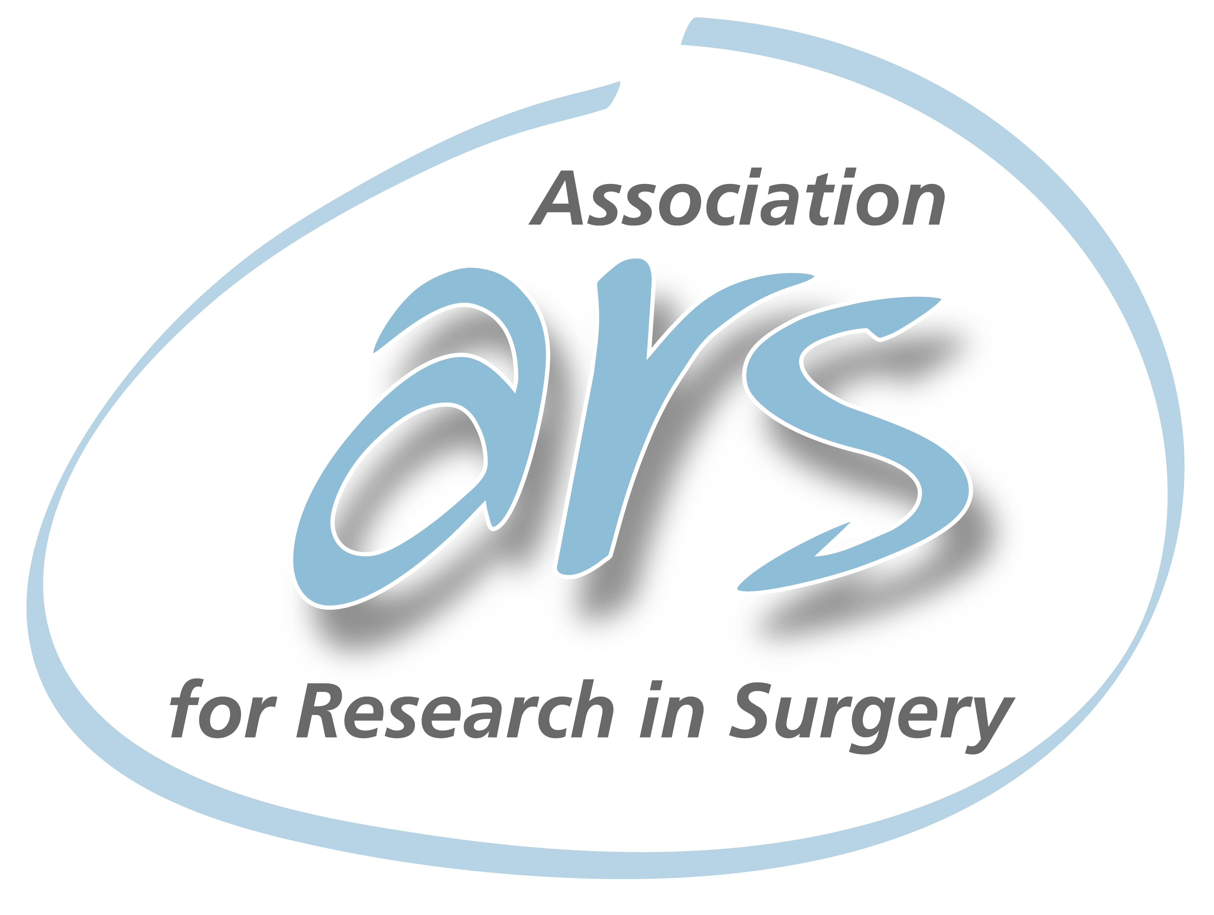
ARS
Association for Research in Surgery

Swiss Surgical Society

(Association for Research in Surgery)
Objectives of the ARS

- To promote and support surgical research in Switzerland

- To promote the interchange between clinical practice and surgical research

- To promote high ethical standards in clinical and basic research

- To provide educational and practical workshops for surgeons at all stages of their career

- To increase collaboration among medical centers in Switzerland and worldwide

Registration for membership:

Family name:
First name:
Title:
Hospital / Organisation:
Town / City:
Postal Code:
Country:
Email:

Please e-mail your registration to:

deborah.stroka@insel.ch

PD Dr. D. Stroka
ARS Secretary

